WAR in EUROPE! – Summer Study Abroad Experience

Travel to Germany, Czech Republic, Hungary, and Poland to Understand the Consequences of War and Genocide
This interdisciplinary program offered by History and Sociology 6 s.h. of credit studying the causes and consequences of war in Europe. While traveling through the Czech Republic,Germany, Hungary, and Poland, students will learn about the impacts of World War II, the Cold War, and the Holocaust through the exploration of various historic sites, museums, and cultural exchanges. Extended excursions included in this trip are: visiting Berlin's "DDR" Cold War Museum, Jewish Holocaust Memorial, and Berlin Wall; Dresden's Military History Museum, Prague's Museum of Communism and Jewish Museum; Krakow's Auschwitz Death Camp; and Budapest's Hammer and Sickle Tour, House of Terror, and the Hospital in the Rock.

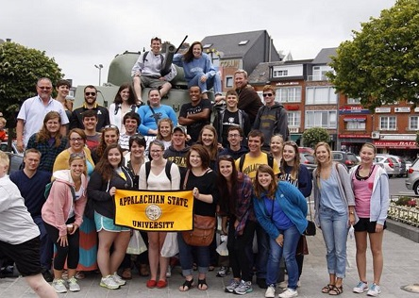
Dates of Travel
May 15 through June 5, 2018

Cities to Visit
Berlin, Dresden, Budapest, Krakow, & Prague

Courses

REQUIRED COURSE FOR ALL STUDENTS:
HIS/SOC 3530: Bloodlands: World War II, Cold War, and the 21st Century – 3 credits

Students must choose one of the following courses:
SOC 3800: Sociology of War – 3 credits
HIS 3535: History of Eastern Europe – 3 credits

For more information, please contact Drs. Jason White (whitejc3@appstate.edu) or Cameron Lippard (lippardcd@appstate.edu).
Next Information Session is September 6th @ 5:30pm 206 Chapell Wilson Hall!

